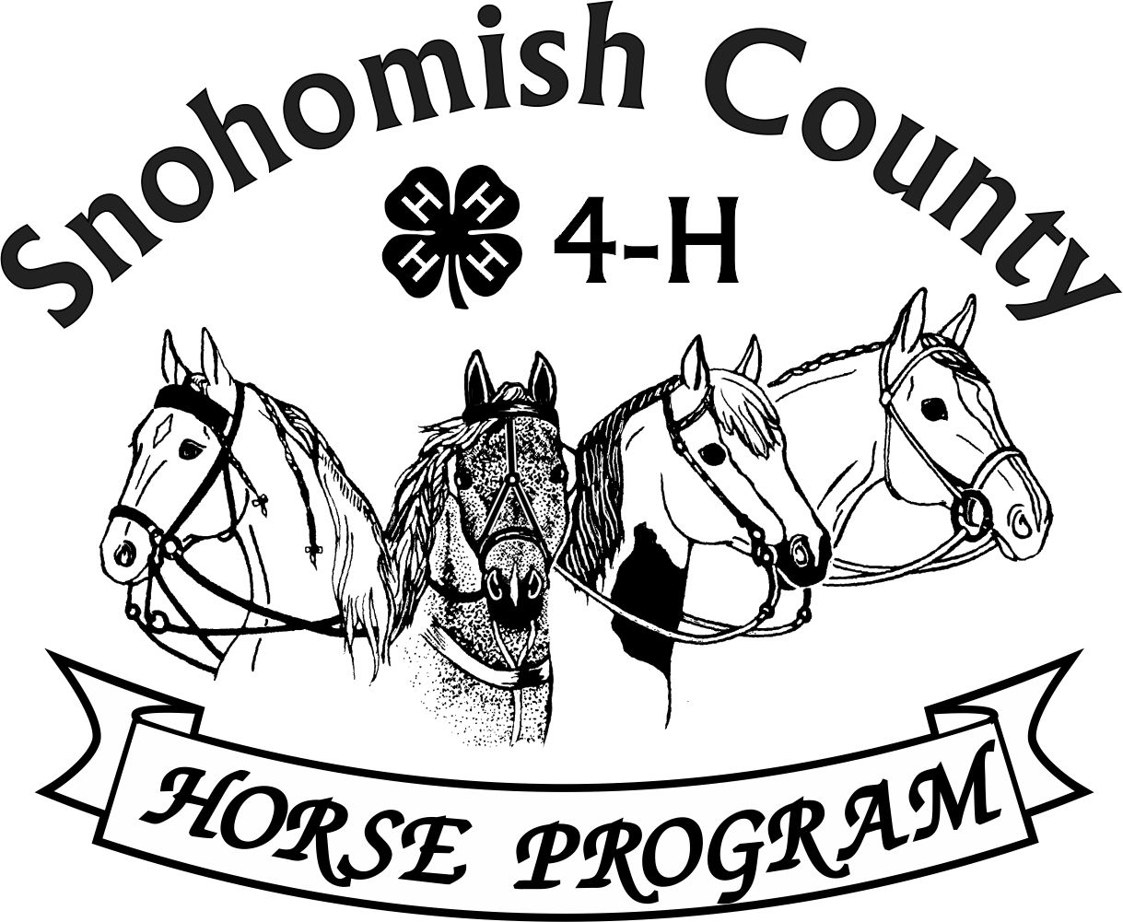
Calendar of Events 4-H Year 2026-2027
NOVEMBER 2026
For current updates, check the Horse Program Website at http://snoco4-hhorse.com/
And on Facebook Snohomish County 4-H Horse Program
NOTE – Members must be enrolled prior to participation in 4-H events
https://v2.4honline.com/#/user/sign-in
The State 4-H Equine Rule Book and the County Reference Guide
have much information about the Program and Events:
http://snoco4-hhorse.com/reference-guides/
November 2026
TUESDAY | 3 | 4-H RIDE NIGHT 6-8pm Fairgrounds
SATURDAY | 7 | FALL RANCH HORSE SHOW - Fairgrounds
SATURDAY | 7 | NATIONAL 4-H CONTESTS in Kentucky!!!!
SATURDAY | 14 | FALL SMALL EQUINE/DRIVING SHOW – Lomara Equestrian Center, Snohomish
SUNDAY | 15 | NOMINATIONS FOR CAROL DONNEL LEADERSHIP AWARD AND ANGEL METCALF SPORTSMANSHIP AWARD DUE
TUESDAY | 17 | 4-H RIDE NIGHT 6-8pm Fairgrounds
TUESDAY | 17 | YOUTH FORUM – 6:30pm Good Shepherd Lutheran Church, 5511 64th ST SE, Snohomish
THURSDAY | 19 | HORSE PROGRAM MEETING 6:30pm Good Shepherd Lutheran Church, 5511 64th ST SE, Snohomish Watch Facebook for Zoom Link

December 2026
TUESDAY | 1 | 4-H RIDE NIGHT 6-8pm Fairgrounds
WEDNESDAY | 2 | HORSE JUDGING #1 6:30pm Fairgrounds
SATURDAY | 12 | YOUTH LEADERSHIP CONFERENCE – WSU EVERETT
TUESDAY | 15 | 4-H RIDE NIGHT 6-8pm Fairgrounds
January 2027
SATURDAY | 2 | FALL WESTERN GAMES SHOW – Fairgrounds
TUESDAY | 5 | 4-H RIDE NIGHT 6-8pm Fairgrounds
SUNDAY | 10 | YEAR END AWARDS – 4pm 4-H Building, Fairgrounds
FRIDAY | 15 | HORSE BOWL #1 6pm, Fairgrounds
TUESDAY | 19 | 4-H RIDE NIGHT 6-8pm Fairgrounds
THURSDAY | 21 | HORSE PROGRAM MEETING 6:30pm Good Shepherd Lutheran Church, 5511 64th ST SE, Snohomish Watch Facebook for Zoom Link
FRIDAY | 22 | HORSE BOWL #2 6pm, Fairgrounds
FRIDAY | 29 | HORSE BOWL #3 6pm, Fairgrounds

February 2027
TUESDAY | 2 | 4-H RIDE NIGHT 6-8pm Fairgrounds
FRIDAY | 5 | HIPPOLOGY #1 6pm, Fairgrounds
FRIDAY | 12 | HIPPOLOGY #2 6pm, Fairgrounds
TUESDAY | 16 | 4-H RIDE NIGHT 6-8pm Fairgrounds
THURSDAY | 18 | HORSE PROGRAM MEETING 6:30pm Good Shepherd Lutheran Church, 5511 64th ST SE, Snohomish Watch Facebook for Zoom Link
FRIDAY | 19 | HIPPOLOGY #3 6pm, Fairgrounds
SATURDAY-SUNDAY | 27-28 | ANNUAL MODEL TRAIN SHOW – Fairgrounds (raises fund for 4-H Council so plan to participate – Council funds pins and grants that benefit all programs!)
SUNDAY | 28 | FALL/WINTER DRESSAGE/WESTERN DRESSAGE SHOW – Fairgrounds

March 2027
SATURDAY` | 6 | ANNUAL TACK SALE – Event Center & 4-H Building, Fairgrounds
THURSDAY | 18 | HORSE PROGRAM MEETING 6:30pm Good Shepherd Lutheran Church, 5511 64th ST SE, Snohomish Watch Facebook for Zoom Link
FRIDAY | 19 | GROOM SQUAD CONTEST - Fairgrounds
FRIDAY-SUNDAY | 19-21 | SPRING PERFORMANCE & HUNTER OVER FENCES SHOW – Fairgrounds  Sat-Western/HOF afternoon-evening and Sun. English

April 2027
THURSDAY | 15 | HORSE PROGRAM MEETING 6:30pm Good Shepherd Lutheran Church, 5511 64th ST SE, Snohomish Watch Facebook for Zoom Link
SATURDAY | 17 | EQUINE-A-RAMA/SUPER SATURDAY - Fairgrounds

May 2027
FRIDAY-SUNDAY | 14-16 | SUMMER PERFORMANCE & HUNTER OVER FENCES SHOW- Fairgrounds  Friday Evening-HOF, Saturday-English and Sunday-Western
SATURDAY | 15 | GROOM SQUAD CONTEST - Fairgrounds
THURSDAY | 18 | HORSE PROGRAM MEETING 6:30pm Good Shepherd Lutheran Church, 5511 64th ST SE, Snohomish Watch Facebook for Zoom Link

YEARLY INFORMATION AND CONTACTS

HORSE PROGRAM MEETINGS  Third Thursday of each month (except for December)  At least one representative per club is requested | Pat Pehling 425 327 6778  programleader@snoco4-hhorse.com
YOUTH FORUM  At least one representative per club is requested | Pat Pehling 425 327 6778  programleader@snoco4-hhorse.com
SCHOLARSHIPS  Due April 1 | LaVonne Bowman  lavbowman@firstam.com  206-445-5100
KNOWLEDGE
EQUINE PRESENTATIONS  County Contest - TBD  State Contest – TBD | Patty Christenson 425-210-6000  rainbowsend7834@cs.com
CLOVERBUD/HORSELESS ACTIVITIES  Watch Calendar and Facebook for information | Patty Christenson 425-210-6000  rainbowsend7834@cs.com
GROOM SQUAD CONTESTS  #1 – March 19  #2 – May 15 | Monica Garbutt  sno.co.groomsquad@gmail.com
HIPPOLOGY CONTESTS  #1 – February 5  #2 – February 12  #3 – February 19  State Contest –May 1, 2027 | Rianan Livingston 360-722-9507  hippology@snoco4-horse.com
HORSE BOWL CONTESTS  #1 – January 15  #2 – January 22  #3 – January 29  State Contest –May 2, 2027 | Margaret Cooper  horsebowl@snoco4-hhorse.com
HORSE JUDGING CONTESTS  #1 – December 2  #2 – TBD  #3 – TBD  #4 – TBD | Pat Pehling 425 327 6778  programleader@snoco4-hhorse.com  Theresa Smith
SHOWS
DRIVING/SMALL EQUINE  Fall – November 14  Spring – TBD  Summer – TBD | Rinda Pullen 425231 7464  ponypower2020@yahoo.com  Cindy Morris 425 308 8527  cindimorris60@gmail.com
DRESSAGE SHOWS  Fall /Winter – February 28, 2027  Spring – TBD  Summer – TBD | Stephanie Portch 425-319-3211  westerndressage@snoco4-hhorse.com

HUNTER OVER FENCES SHOWS  Fall – October 30  Spring – March 20  Summer – May 14  Fall – TBD | Sandra Green  hunteroverfences@snoco4-hhorse.com
PERFORMANCE SHOWS  Fall – October 30-Nov.1  Spring – March 19-21  Summer – May 14-16 (NOTE CHANGE OF DATE)  Fall – October 29-31 | Lavonne Bowman  performance@snoco4-hhorse.com  Laurie Johnson (Show Registrar)  206-930-3844 (text)  lauriecm@gmail.com
RANCH HORSE  Fall – November 7  Spring – TBD  Summer – TBD | Sarah Gunderson 206-290-0506  sarahgcpa@gmail.com  Kyri McCoy

TRAIL HORSE CLASS IN THE FIELD  TBD | Avery Christenson 425 760 6730 trailhorseclassinthefield@snoco4-hhorse.com
WESTERN DRESSAGE SHOWS  Fall/Winter – February 28, 2027  Spring – TBD  Summer – TBD | Stephanie Portch 425-319-3211 westerndressage@snoco4-hhorse.com

WESTERN GAMES SHOWS  Fall/Winter – January 2, 2027  Spring – TBD  Summer – TBD | Billi Startzman 425-344-5873  westerngames@snoco4-hhorse.com
FAIR
EVERGREEN STATE FAIR -2027  August 25-Sept.2 | Laurie Johnson 206-930-3844 (text)  fairsuperintendent@snoco4-hhorse.com  lauriecm@gmail.com
STATE FAIR
WASHINGTON STATE 4-H FAIR 2027  September 8-26, 2027 | Pat Pehling 425 327 6778  programleader@snoco4-hhorse.com
NATIONALS
KENTUCKY NATIONALS 2026  November 6-8, 2026  https://www.4hroundup.com/contest-info | RA Mazzola 206-799-5466  ramazzola@aol.com  Pat Pehling 425 327 6778  programleader@snoco4-hhorse.com
TACK SALE
March 6, 2027 | Pat Pehling 425 327 6778  programleader@snoco4-hhorse.com  Jennifer Munson 425 471 4532  munson.jenniferl@gmail.com
EQUINE-A-RAMA
April 17, 2027 | Patty Christenson 425-210-6000  rainbowsend7834@cs.com

4-H Horse Program Officers
Pat Pehling – Program Leader
Lindsay Matter – President /President Elect – LaVonne Bowman
Sarah Norris-Henricksen – Vice President
LaVonne Bowman – Secretary / Secretary Elect – Mary Palmer
Billi Startzman – Treasurer

