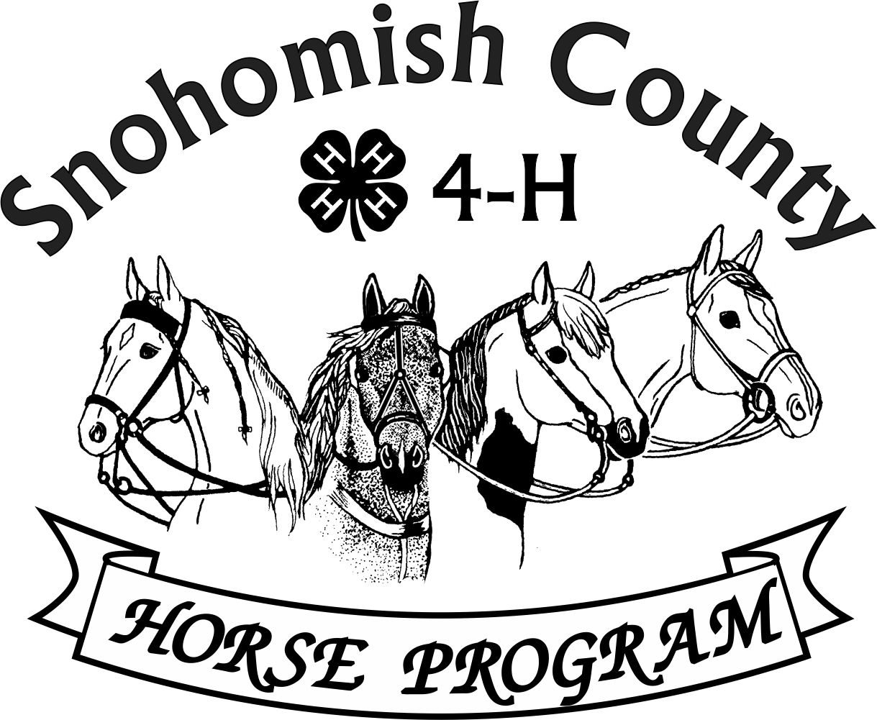
Calendar of Events 4-H Year 2025-2026
MAY 2026
For current updates, check the Horse Program Website at http://snoco4-hhorse.com/
And on Facebook Snohomish County 4-H Horse Program
NOTE – Members must be enrolled prior to participation in 4-H events
https://v2.4honline.com/#/user/sign-in
The State 4-H Equine Rule Book and the County Reference Guide
have much information about the Program and Events:
http://snoco4-hhorse.com/reference-guides/
MAY 2026
SATURDAY | 2 | STATE 4-H HIPPOLOGY CONTEST – Moses Lake, Grant County Fairgrounds
SUNDAY | 3 | STATE 4-H HORSE BOWL CONTEST -Moses Lake, Grant County Fairgrounds
SATURDAY | 9 | RANCH HORSE SHOW – BLT Arena, 21711 Waite Mill Road, Granite Falls
SUNDAY | 10 | STALL CLEANING FUND RAISING FOR HORSE PROGRAM – Bring shovels, brooms but no wheelbarrows – Fairgrounds 6pm PLEASE HELP IF YOU CAN!
SATURDAY | 16 | STATE 4-H EQUINE PRESENTATIONS VIRTUAL CONTST  (Seniors and Intermediates)
SATURDAY | 16 | HORSE JUDGING #4 – 1:30pm Eagle Mountain Ranch, 805 Lakewood Road, Arlington
SUNDAY | 17 | SHOW STOPPERS PRIZE RIDE - Pilchuck Tree Farm, Arlington
THURSDAY | 21 | HORSE PROGRAM MEETING 6:30pm Good Shepherd Lutheran Church, 5511 64th ST SE, Snohomish Watch Facebook for Zoom Link
FRIDAY | 29 | VOLUNTEER ROUND UP HUB – Fairgrounds – 7pm – An opportunity to learn about all the volunteer opportunities and needs at the Show – for adults and youth – no need to be enrolled!
SATURDAY | 30 | CLOVERBUD EVENT – Fairgrounds – meet at 1pm near the Concession Stand
FRIDAY-  SUNDAY | 29-31 | SUMMER PERFORMANCE & HOF SHOW – Fairgrounds  Friday /Evening - Hunter Over Fences/Saturday-English Performance/Sunday-Western Performance
SATURDAY | 30 | GROOM SQUAD CONTEST – Fairgrounds Indoor Arena 6pm

JUNE 2026
MONDAY | 1 | HORSE CERTIFICATES DUE TO EXHBIT AT FAIR – for new members, for current members with new horse and members who changed clubs – form available on Website listed above
SATURDAY | 6 | WORK PARTY at Pilchuck Tree Farm – Need help so we can have the August 8 Ride
SUNDAY1 | 7 | STALL CLEANING FUND RAISER FOR COUNTY PROGRAM – Fairgrounds  Meet at 6pm at Canopy near restrooms, bring shovels and brooms – support the Program so all the activities can happen!
TUESDAY | 9 | PREPARE FOR FAIR WORKSHOP – For volunteers and youth – 6:30pm – Good Shepherd Lutheran Church, 5511 64th ST SE, Snohomish (There will be a hybrid option)
SUNDAY | 14 | SUMMER WESTERN GAMES SHOW – Stanwood Equestrian Center
THURSDAY | 18 | HORSE PROGRAM MEETING 6:30pm Good Shepherd Lutheran Church, 5511 64th ST SE, Snohomish Watch Facebook for Zoom Link
SATURDAY | 20 | SPRING DRIVING/SMALL EQUINE SHOW – Lomara Equestrian Center, Snohomish
SUNDAY | 21 | SPRING DRESSAGE/WESTERN DRESSAGE SHOW – Hollywood Hills Saddle Club
SATURDAY-  SUNDAY | 26-27 | WASHINGTON STATE JUNIOR HORSE SHOW – Moses Lake, Grant County Fairground
SATURDAY | 27 | SPRING RANCH HORSE SHOW – Location TBD

JULY 2026
SATURDAY | 11 | SUMMER DRIVING/SMALL EQUINE SHOW – BLT Arena, 21711 Waite Mill Road, Granite Falls
THURSDAY | 18 | HORSE PROGRAM MEETING 6:30pm Good Shepherd Lutheran Church, 5511 64th ST SE, Snohomish Watch Facebook for Zoom Link
SUNDAY | 26 | SUMMER RANCH HORSE SHOW – BLT Arena, 21711 Waite Mill Road, Granite Falls

AUGUST 2026
SATURDAY | 8 | TRAIL HORSE CLASS IN THE FIELD – Pilchuck Tree Farm, Arlington (4-H Adults may compete!)
THURSDAY | 20 | HORSE PROGRAM MEETING 6:30pm Good Shepherd Lutheran Church, 5511 64th ST SE, Snohomish Watch Facebook for Zoom Link
WEDNESDAY-  THURSDAY | 26-  Sept.3 | COUNTY 4-H HORSE EXHIBIT – Monroe Fairgrounds

SEPTEMBER 2026
WEDNESDAY-  SUNDAY | 9-27 | WASHINGTON STATE 4-H FAIR – Puyallup  Schedule not yet available
THURSDAY | 17 | HORSE PROGRAM MEETING 6:30pm Good Shepherd Lutheran Church, 5511 64th ST SE, Snohomish Watch Facebook for Zoom Link

OCTOBER 2026
WEDNESDAY | 1 | ENROLLMENT OPENS – Required prior to participation in any 4-H activity for new and returning members
THURSDAY | 15 | HORSE PROGRAM MEETING 6:30pm Good Shepherd Lutheran Church, 5511 64th ST SE, Snohomish Watch Facebook for Zoom Link
FRIDAY-  SUNDAY | 30-  NOV. 1 | FALL PERFORMANCE & HOF SHOW – Fairgrounds  Friday /Evening - Hunter Over Fences/Saturday-English Performance/Sunday-Western Performance
FRIDAY-  SUNDAY | 30-  NOV. 1 | WASHINGTON STATE 4-H HORSE JUDGES SCHOOL – to be held at the Snohomish County 4-H Show

YEARLY INFORMATION AND CONTACTS

HORSE PROGRAM MEETINGS  Third Thursday of each month (except for December)  At least one representative per club is requested | Pat Pehling 425 327 6778  programleader@snoco4-hhorse.com
YOUTH FORUM  At least one representative per club is requested | Pat Pehling 425 327 6778  programleader@snoco4-hhorse.com
SCHOLARSHIPS  Due April 1 | LaVonne Bowman  lavbowman@firstam.com  206-445-5100

KNOWLEDGE
EQUINE PRESENTATIONS  County Contest - April 25  State Contest – May 16 (Virtual) | Patty Christenson 425-210-6000  rainbowsend7834@cs.com
CLOVERBUD/HORSELESS ACTIVITIES  Watch Calendar and Facebook for information | Patty Christenson 425-210-6000  rainbowsend7834@cs.com
GROOM SQUAD CONTESTS  #1 – March 20  #2 – May 30  State Contest (Senior only) September 12 | Monica Garbutt  sno.co.groomsquad@gmail.com
HIPPOLOGY CONTESTS  #1 – January 30  #2 – February 13  #3 – February 27  State Contest –May 2, 2026 | Rianan Livingston 360-722-9507  hippology@snoco4-horse.com

HORSE BOWL CONTESTS  #1 – November 21  #2 – January 4  #3 – January 16  State Contest –May 3, 2026 | Margaret Cooper  horsebowl@snoco4-hhorse.com
HORSE JUDGING CONTESTS  #1 – October 22,2025  #2 – March 17  #3 – April 15  #4 – May 16  State Contest – September 12 | Pat Pehling 425 327 6778  programleader@snoco4-hhorse.com  Theresa Smith
SHOWS

DRIVING/SMALL EQUINE  Fall – October 18  Spring – June 20  Summer – July 11 | Ginger Kunz 815-904-4432  ponypower2020@yahoo.com  Cindy Morris
DRESSAGE SHOWS  Fall /Winter – February 1 2026  Spring – June 21  Summer – TBD | Stephanie Portch 425-319-3211  westerndressage@snoco4-hhorse.com

HUNTER OVER FENCES SHOWS  Fall – October 3  Spring – March 21  Summer – May 29  Fall – October 30 | Sandra Green  hunteroverfences@snoco4-hhorse.com
PERFORMANCE SHOWS  Fall – October 4-5  Spring –March 20-22  Summer –May 29-31 (NOTE CHANGE OF DATE!)  Fall – October 30-Nov.1 | Katie Norris Antonio  performance@snoco4-hhorse.com  Laurie Johnson (Show Registrar)  206-930-3844 (text)  lauriecm@gmail.com
RANCH HORSE  Fall/Winter–May 9  Spring – June 27  Summer –July 26  Fall-- TBD | Sarah Gunderson 206-290-0506  sarahgcpa@gmail.com  Kyri McCoy

TRAIL HORSE CLASS IN THE FIELD  August 8 - Pilchuck Tree Farm  Work Party – June 6 | Avery Christenson 425 760 6730 trailhorseclassinthefield@snoco4-hhorse.com  Pat Pehling 425 327 6778  programleader@snoco4-hhorse.com
WESTERN DRESSAGE SHOWS  Fall/Winter – February 1 2026  Spring – June 21  Summer – TBD | Stephanie Portch 425-319-3211 westerndressage@snoco4-hhorse.com

WESTERN GAMES SHOWS  Fall – November 1, 2025  Spring – April 19  Summer – June 14  Fall – TBD | Billi Startzman 425-344-5873  westerngames@snoco4-hhorse.com
FAIR
EVERGREEN STATE FAIR -2026  August 27-Sept.3 | fairsuperintendent@snoco4-hhorse.com  Laurie Johnson (Assistant) 206-930-3844 (text)  lauriecm@gmail.com
STATE FAIR
WASHINGTON STATE 4-H FAIR | Pat Pehling 425 327 6778  programleader@snoco4-hhorse.com
NATIONALS
KENTUCKY NATIONALS 2026  November 6-8, 2026  https://www.4hroundup.com/contest-info | RA Mazzola 206-799-5466  ramazzola@aol.com  Pat Pehling 425 327 6778  programleader@snoco4-hhorse.com
TACK SALE
March 7, 2026 | Pat Pehling 425 327 6778  programleader@snoco4-hhorse.com  Jennifer Munson 425 471 4532  munson.jenniferl@gmail.com
EQUINE-A-RAMA
April 18, 2026 | Patty Christenson 425-210-6000  rainbowsend7834@cs.com
4-H Horse Program Officers
Pat Pehling – Program Leader
Lindsay Matter - President
Sarah Norris-Henricksen – Vice President
LaVonne Bowman – Secretary
Billi Startzman – Treasurer

