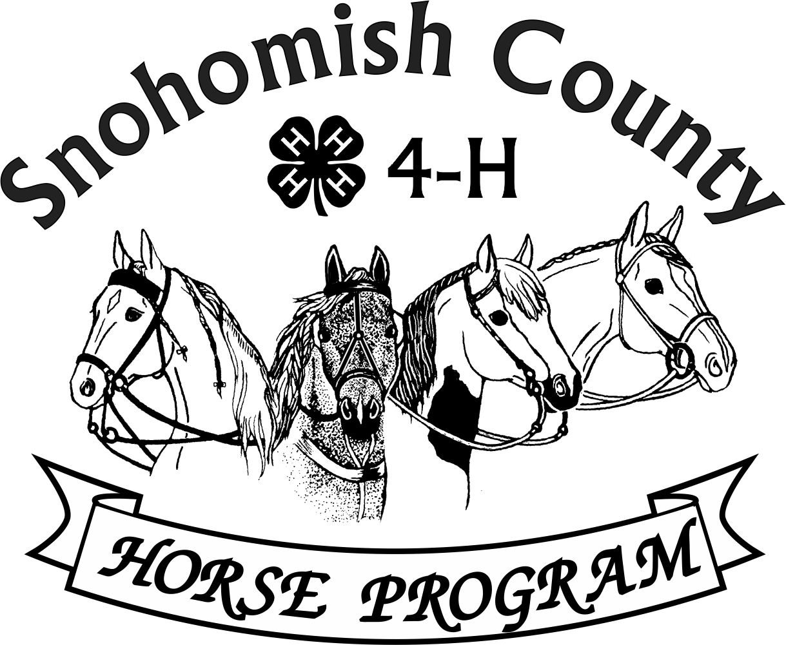
Calendar of Events 4-H Year 2025-2026
FEBRUARY 2026
For current updates, check the Horse Program Website at http://snoco4-hhorse.com/
And on Facebook Snohomish County 4-H Horse Program
NOTE – Members must be enrolled prior to participation in 4-H events
https://v2.4honline.com/#/user/sign-in
The State 4-H Equine Rule Book and the County Reference Guide
have much information about the Program and Events:
http://snoco4-hhorse.com/reference-guides/
Note – Winter Events are Weather permitting (check facebook if questionable )

FEBRUARY 2026
SATURDAY | 1 | WINTER DRESSAGE/WESTERN DRESSAGE SHOW - Fairgrounds
FRIDAY | 13 | HIPPOLOGY #2 6pm Display Hall, Fairgrounds
WEDNESDAY | 11 | RIDE NIGHT 6-8pm Fairgrounds Indoor Arena
THURSDAY | 19 | HORSE PROGRAM MEETING 6:30pm  Good Shepherd Lutheran Church, 5511 64th ST SE, Snohomish  Watch Facebook for Zoom Link
FRIDAY-  SUNDAY | 20-22 | MODEL TRAIN SHOW – Fairgrounds  4-H COUNCIL FUND RAISER – Please sign up to help!
WEDNESDAY | 25 | RIDE NIGHT 6-8pm Fairgrounds Indoor Arena
FRIDAY | 27 | HIPPOLOGY #3 6pm Display Hall, Fairgrounds

MARCH 2026
MONDAY-  WEDNESDAY | 2-4 | TACK SALE SET UP – Fairgrounds Event Center and 4-H Building – Sign Up Genius Link:  https://www.signupgenius.com/go/4090F4FA9AC22ABFD0-61521166-4htack?fbclid=IwY2xjawPmIK5leHRuA2FlbQIxMQBzcnRjBmFwcF9pZBAyMjIwMzkxNzg4MjAwODkyAAEey_lBxkmefOv0cj_y-a6Ay-Aq33qkmKiC6ugRO2Rnn4hu6qAvMJMiZvjKk94_aem_e8Y_XjE5yiO21kpXoBhBpg#/
THURSDAY-  FRIDAY | 5-6 | TACK SALE CONSIGNMENTS – Fairgrounds Event Center
SATURDAY | 7 | TACK SALE - Fairgrounds Event Center 10am-3pm (Consignment sorting 3pm to when done)
SUNDAY | 8 | TACK SALE CONSIGNMENT PICK UP 11am-3pm  LITTLE TACK SALE (most donated items ½ price to 4-H families) – 4 or 5pm  Both at Fairgrounds Event Center
WEDNESDAY | 11 | RIDE NIGHT 6-8pm Fairgrounds Outdoor Covered Arena
THURSDAY | 19 | HORSE PROGRAM MEETING 6:30pm Good Shepherd Lutheran Church, 5511 64th ST SE, Snohomish Watch Facebook for Zoom Link
FRIDAY-  SUNDAY | 20-22 | SPRING PERFORMANCE & HOF SHOW – Fairgrounds  Saturday-Western Performance  Saturday Afternoon/Evening - Hunter Over Fences  Sunday-English Performance
FRIDAY | 2O | GROOM SQUAD CONTEST 6:30pm (Fairgrounds Indoor Arena)

APRIL 2026
THURSDAY | 16 | HORSE PROGRAM MEETING 6:30pm Good Shepherd Lutheran Church, 5511 64th ST SE, Snohomish Watch Facebook for Zoom Link
SATURDAY | 18 | EQUINE-A-RAMA/SUPER SATURDAY – 4-H Building & Livestock Arena
SUNDAY | 19 | SPRING WESTERN GAMES SHOW – BLT Arena, Granite Falls
SATURDAY | 25 | COUNTY 4-H EQUINE PRESENTATIONS CONTEST –(Intermediates and Seniors)  Pre-Registration required – Watch Facebook  Time TBD Good Shepherd Lutheran Church, 5511 64th ST SE, Snohomish

MAY 2026
SATURDAY | 2 | STATE 4-H HIPPOLOGY CONTEST – Moses Lake, Grant County Fairgrounds
SUNDAY | 3 | STATE 4-H HORSE BOWL CONTEST -Moses Lake, Grant County Fairgrounds
SATURDAY | 16 | STATE 4-H EQUINE PRESENTATIONS VIRTUAL CONTST  (Seniors and Intermediates)
THURSDAY | 21 | HORSE PROGRAM MEETING 6:30pm Good Shepherd Lutheran Church, 5511 64th ST SE, Snohomish Watch Facebook for Zoom Link
FRIDAY-  SUNDAY | 29-31 | SUMMER PERFORMANCE & HOF SHOW – Fairgrounds  Friday /Evening - Hunter Over Fences  Saturday-English Performance  Sunday-Western Performance

JUNE 2026
SUNDAY | 14 | SUMMER WESTERN GAMES SHOW – Stanwood Equestrian Center
THURSDAY | 18 | HORSE PROGRAM MEETING 6:30pm Good Shepherd Lutheran Church, 5511 64th ST SE, Snohomish Watch Facebook for Zoom Link
SATURDAY-  SUNDAY | 26-27 | WASHINGTON STATE JUNIOR HORSE SHOW – Moses Lake, Grant County Fairground

YEARLY INFORMATION AND CONTACTS

HORSE PROGRAM MEETINGS  Third Thursday of each month (except for December)  At least one representative per club is requested | Pat Pehling 425 327 6778  programleader@snoco4-hhorse.com
YOUTH FORUM  At least one representative per club is requested | Pat Pehling 425 327 6778  programleader@snoco4-hhorse.com
SCHOLARSHIPS  Due April 1 | LaVonne Bowman  lavbowman@firstam.com  206-445-5100

KNOWLEDGE
EQUINE PRESENTATIONS  County Contest - April 25  State Contest – May 16 (Virtual) | Patty Christenson 425-210-6000  rainbowsend7834@cs.com
CLOVERBUD/HORSELESS ACTIVITIES  Watch Calendar and Facebook for information | Patty Christenson 425-210-6000  rainbowsend7834@cs.com
GROOM SQUAD CONTESTS  #1 – March 20 | Monica Garbutt  sno.co.groomsquad@gmail.com
HIPPOLOGY CONTESTS  #1 – January 30  #2 – February 13  #3 – February 27  State Contest –May 2, 2026 | Rianan Livingston 360-722-9507  hippology@snoco4-horse.com

HORSE BOWL CONTESTS  #1 – November 21  #2 – January 4 (rescheduled)  #3 – January 16  State Contest –May 3, 2026 | Margaret Cooper  horsebowl@snoco4-hhorse.com
HORSE JUDGING CONTESTS  #1 – October 22,2025  #2 – TBD  #3 – TBD  #4 – TBD  State Contest – September 12 (Tentative date) | Pat Pehling 425 327 6778  programleader@snoco4-hhorse.com  Theresa Smith
SHOWS

DRIVING/SMALL EQUINE  Fall – October 18  Spring – TBD  Summer – TBD | Ginger Kunz 815-904-4432  ponypower2020@yahoo.com
DRESSAGE SHOWS  Fall /Winter – February 1 2026  Spring – TBD  Summer – TBD | Stephanie Portch 425-319-3211  westerndressage@snoco4-hhorse.com

HUNTER OVER FENCES SHOWS  Fall – October 3  Spring – March 21  Summer – May 29 | Sandra Green  hunteroverfences@snoco4-hhorse.com
PERFORMANCE SHOWS  Fall – October 4-5  Spring –March 20-22  Summer –May 29-31 (NOTE CHANGE OF DATE!)  Fall – October 30-Nov.1 | Katie Norris Antonio  performance@snoco4-hhorse.com  Laurie Johnson (Show Registrar)  206-930-3844 (text)  lauriecm@gmail.com
RANCH HORSE  Fall/Winter– TBD  Spring – TBD  Summer – TBD  Fall-- TBD | Sarah Gunderson 206-290-0506  sarahgcpa@gmail.com  Kyri McCoy

TRAIL HORSE CLASS IN THE FIELD  TBD | Ariana Marquez trailhorseclassinthefield@snoco4-hhorse.com  Pat Pehling 425 327 6778  programleader@snoco4-hhorse.com
WESTERN DRESSAGE SHOWS  Fall/Winter – February 1 2026  Spring – TBD  Summer – TBD | Stephanie Portch 425-319-3211 westerndressage@snoco4-hhorse.com

WESTERN GAMES SHOWS  Fall – November 1, 2025  Spring – April 19  Summer – June 14  Fall – TBD | Billi Startzman 425-344-5873  westerngames@snoco4-hhorse.com

FAIR
EVERGREEN STATE FAIR -2026  August 27-Sept.3 | Melinda Nelson 425-737-2700  fairsuperintendent@snoco4-hhorse.com  Jennifer Munson (Assistant) 425 471 4532  munson.jenniferl@gmail.com  Laurie Johnson (Assistant) 206-930-3844 (text)  lauriecm@gmail.com
STATE FAIR
WASHINGTON STATE 4-H FAIR | Pat Pehling 425 327 6778  programleader@snoco4-hhorse.com
NATIONALS
KENTUCKY NATIONALS 2026  TBD | RA Mazzola 206-799-5466  ramazzola@aol.com  Pat Pehling 425 327 6778  programleader@snoco4-hhorse.com
TACK SALE
March 7, 2026 | Pat Pehling 425 327 6778  programleader@snoco4-hhorse.com  Jennifer Munson 425 471 4532  munson.jenniferl@gmail.com
EQUINE-A-RAMA
April 18, 2026 | Patty Christenson 425-210-6000  rainbowsend7834@cs.com
4-H Horse Program Officers
Pat Pehling – Program Leader
Lindsay Matter - President
Sarah Norris-Henricksen – Vice President
LaVonne Bowman – Secretary
Billi Startzman – Treasurer

