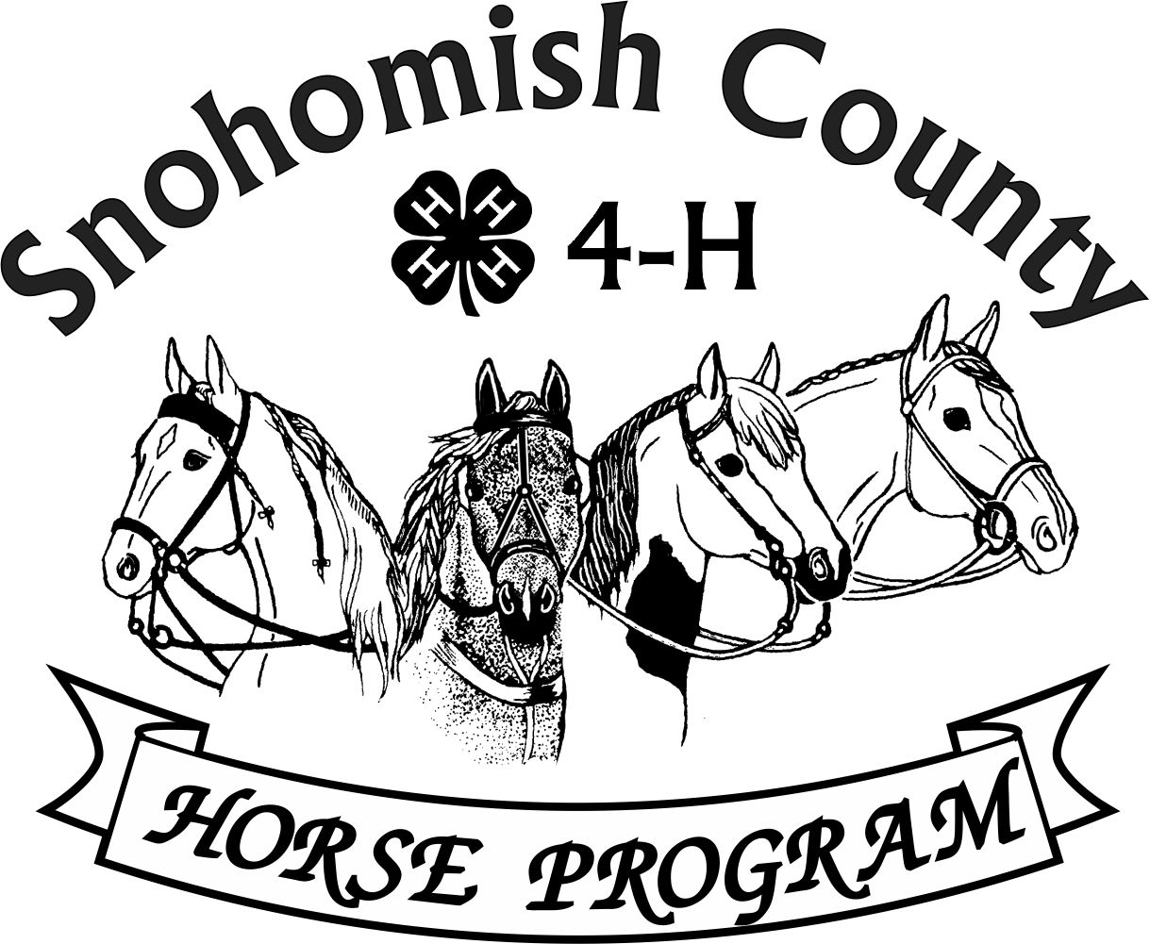

Calendar of Events 4-H Year 2024- 2025

JUNE 2025

***For current updates, check the Horse Program Website at*** [***http://snoco4-hhorse.com/***](http://snoco4-hhorse.com/)

***And on Facebook*** [***Snohomish County 4-H Horse Program***](https://urldefense.com/v3/__https:/www.facebook.com/groups/SnohomishCO4HEquine/?ref=group_header__;!!JmPEgBY0HMszNaDT!7vWm4SARBEwaY3tou7lvJWLoUntVhIjeIfKIFKC44QGkWnV6GeRPaPrXuQ9Rq2oz$)

***NOTE – Members must be enrolled prior to participation in 4-H events***

[***https://v2.4honline.com/#/user/sign-in***](https://v2.4honline.com/#/user/sign-in)

**The State 4-H Equine Rule Book and the County Reference Guide**

**have much information about the Program and Events:**

[**http://snoco4-hhorse.com/reference-guides/**](http://snoco4-hhorse.com/reference-guides/)

**JUNE 2025**

|  |  |  |
| --- | --- | --- |
| SUNDAY | 1 | SUMMER PERFORMANCE SHOWS – Fairgrounds  English Performance |
| SUNDAY | 8 | SPRING WESTERN GAMES SHOW – Stanwood Equestrian Center |
| MONDAY | 9 | HORSE JUDGING #4 – Fairgrounds 6pm Registration and Orientation for newer members Classes start at 6:30pm Wear Arena-appropriate shoes, bring a pen/pencil and clipboards are handy! |
| TUESDAY | 10 | PREPARE FOR FAIR WORKSHOP – 6:30pm Good Shepherd Lutheran Church, 5511 64th ST SE, Snohomish or watch Facebook for the ZOOM Link |
| SUNDAY | 15 | SPRING DRESSAGE & WESTERN DRESSAGE SHOWS – Hollywood Hills Saddle Club, Woodinville |
| THURSDAY | 19 | HORSE PROGRAM MEETING 6:30pm  Good Shepherd Lutheran Church, 5511 64th ST SE, Snohomish  Watch Facebook for Zoom Link |
| SATURDAY | 21 | SUMMER RANCH HORSE SHOW – Hollywood Hills Saddle Club, Woodinville |
| THURSDAY-  SUNDAY | 26-29 | WASHINGTON STATE JUNIOR HORSE SHOW & CLINIC- Grant County Fairgrounds  [Events for May 2025 | Yakima County | Washington State University](https://extension.wsu.edu/yakima/event/washington-state-junior-horse-show-2/) |

**JULY 2025**

|  |  |  |
| --- | --- | --- |
| THURSDAY | 17 | HORSE PROGRAM MEETING 6:30pm  Good Shepherd Lutheran Church, 5511 64th ST SE, Snohomish  Watch Facebook for Zoom Link |
| SUNDAY | 26 | SUMMER DRESSAGE & WESTERN DRESSAGE SHOWS – Hollywood Hills Saddle Club, Woodinville |
| SATURDAY | 26 | SUMMER WESTERN GAMES SHOW – Bits & Spurs Arena, 15703 Grant Creek Rd, Arlington |

**AUGUST 2025**

|  |  |  |
| --- | --- | --- |
| THURSDAY | 14 | HORSE PROGRAM MEETING 6:30pm (NOTE-2nd Thursday due to conflict with Fair Dates and change of location to Extension Office at Willis Tucker County Park)  Watch Facebook for Zoom Link |
| SUNDAY | 17 | GROOM SQUAD CONTEST – Fairgrounds |
| MONDAY | 18 | HORSE SHOP & POSTER CHECK IN |
| WEDNESDAY-  SATURDAY | 20-23 | SENIOR PERFORMANCE SECTION |
| SATURDAY-  MONDAY | 23-25 | WESTERN GAMES & JUNIOR PERFORMANCE SECTION |
| MONDAY-  THURSDAY | 25-28 | INTERMEDIATE PERFORMANCE SECTION |
| THURSDAY | 28 | HORSE SHOP & POSTER PICK UP |
| WEDNESDAY | 27 | 4-H BARN DANCE 6-8pm (no parking fee or entry fee with fair closed to the public) |

**YEARLY INFORMATION AND CONTACTS**

|  |  |
| --- | --- |
| **HORSE PROGRAM MEETINGS**  Third Thursday of each month (except for December)  At least one representative per club is requested | Pat Pehling 425 327 6778  [programleader@snoco4-hhorse.com](mailto:programleader@snoco4-hhorse.com) |
| **YOUTH FORUM**  At least one representative per club is requested | Pat Pehling 425 327 6778  [programleader@snoco4-hhorse.com](mailto:programleader@snoco4-hhorse.com) |
| **SCHOLARSHIPS** | LaVonne Bowman |

**KNOWLEDGE**

|  |  |
| --- | --- |
| **EQUINE PRESENTATIONS**  County Contest – March 8  State Contest – March 22 | Patty Christenson 425-210-6000  [rainbowsend7834@cs.com](mailto:rainbowsend7834@cs.com) |
| **CLOVERBUD/HORSELESS ACTIVITIES**  Watch Calendar and Facebook for information | Patty Christenson 425-210-6000  [rainbowsend7834@cs.com](mailto:rainbowsend7834@cs.com) |
| **GROOM SQUAD CONTESTS**  April 26  August 17  State Contest – September 6 | Monica Garbutt  [groomsquad@snoco4-hhorse.com](mailto:groomsquad@snoco4-hhorse.com) |
| **HIPPOLOGY CONTESTS**  #1 –January 19  #2 – January 31  #3 – February 14  State Contest –May 3 | Rianan Livingston 360-722-9507  [hippology@snoco4-horse.com](mailto:hippology@snoco4-horse.com) |

|  |  |
| --- | --- |
| **HORSE BOWL CONTESTS**  #1 – November 22  #2 – December 1  #3 – January 3  State Contest –May 4 | Margaret Cooper  horsebowl@snoco4-hhorse.com |
| **HORSE JUDGING CONTESTS**  #1 – October 24  #2 – March 22  #3 – May 22  #4 – June 9  State Contest – September 6 | Pat Pehling 425 327 6778  [programleader@snoco4-hhorse.com](mailto:programleader@snoco4-hhorse.com)  Teresa Smith | |

**SHOWS**

|  |  |
| --- | --- |
| **DRIVING/SMALL EQUINE**  Fall – October 4-5  Spring – March 15-16  Summer – May 30-May 31 | Ginger Kunz 815-904-4432  [ponypower2020@yahoo.com](mailto:ponypower2020@yahoo.com) |
| **DRESSAGE SHOWS**  Fall /Winter – February 23  Spring – June 15  Summer – July 26 | Stephanie Portch 425-319-3211  [westerndressage@snoco4-hhorse.com](mailto:westerndressage@snoco4-hhorse.com) |

|  |  |
| --- | --- |
| **HUNTER OVER FENCES SHOWS**  Fall – October 5  Spring – March 14  Summer – May 31 | Stephanie Castner  [hunteroverfences@snoco4-hhorse.com](mailto:hunteroverfences@snoco4-hhorse.com)  Sandra Green |
| **PERFORMANCE SHOWS**  Fall – October 4-5  Spring – March 14-16  Summer – May 30-June 1  Fall – October  3-5, 2025 | Katie Norris  [performance@snoco4-hhorse.com](mailto:performance@snoco4-hhorse.com)  Laurie Johnson (Show Registrar)  206-930-3844 (text)  [lauriecm@gmail.com](mailto:lauriecm@gmail.com) |
| **RANCH HORSE**  Fall – November 3  Spring – May18  Summer –June 21 | Sarah Gunderson 206-290-0506  [sarahgcpa@gmail.com](mailto:sarahgcpa@gmail.com)  Kyri McCoy |

|  |  |
| --- | --- |
| **TRAIL HORSE CLASS IN THE FIELD**  TBD | Ariana Marquez [trailhorseclassinthefield@snoco4-hhorse.com](mailto:trailhorseclassinthefield@snoco4-hhorse.com)  Pat Pehling 425 327 6778  [programleader@snoco4-hhorse.com](mailto:programleader@snoco4-hhorse.com) |
| **WESTERN DRESSAGE SHOWS**  Fall/Winter – February 23  Spring – June 15  Summer – July 26 | Stephanie Portch 425-319-3211 [westerndressage@snoco4-hhorse.com](mailto:westerndressage@snoco4-hhorse.com) | |

|  |  |
| --- | --- |
| **WESTERN GAMES SHOWS**  Fall – November 2  Spring – June 8  Summer – July 26 (tentative)  Fall – November 3, 2025 | Billi Startzman 425-344-5873  [westerngames@snoco4-hhorse.com](mailto:westerngames@snoco4-hhorse.com) |

**FAIR**

|  |  |
| --- | --- |
| EVERGREEN STATE FAIR  August 20-28 | Melinda Nelson 425-737-2700  [fairsuperintendent@snoco4-hhorse.com](mailto:fairsuperintendent@snoco4-hhorse.com)  Laurie Johnson (Assistant) 206-930-3844 (text)  lauriecm@gmail.com |

**STATE FAIR**

|  |  |
| --- | --- |
| WASHINGTON STATE 4-H FAIR | Pat Pehling 425 327 6778  [programleader@snoco4-hhorse.com](mailto:programleader@snoco4-hhorse.com) |

**NATIONALS**

|  |  |
| --- | --- |
| KENTUCKY NATIONALS 2025  November 8-9 | RA Mazzola 206-799-5466  [ramazzola@aol.com](mailto:ramazzola@aol.com)  Pat Pehling 425 327 6778  [programleader@snoco4-hhorse.com](mailto:programleader@snoco4-hhorse.com) |

**TACK SALE**

|  |  |
| --- | --- |
| March 1, 2025 | Pat Pehling 425 327 6778  [programleader@snoco4-hhorse.com](mailto:programleader@snoco4-hhorse.com)  Jennifer Munson 425 471 4532  [munson.jenniferl@gmail.com](mailto:munson.jenniferl@gmail.com) |

**EQUINE-A-RAMA**

|  |  |
| --- | --- |
| March 29, 2025 | Patty Christenson 425-210-6000  [rainbowsend7834@cs.com](mailto:rainbowsend7834@cs.com) |

4-H Horse Program Officers

Pat Pehling – Program Leader

Lindsay Matter - President

Sarah Norris-Henricksen – Vice President

LaVonne Bowman – Secretary

Billi Startzman – Treasurer