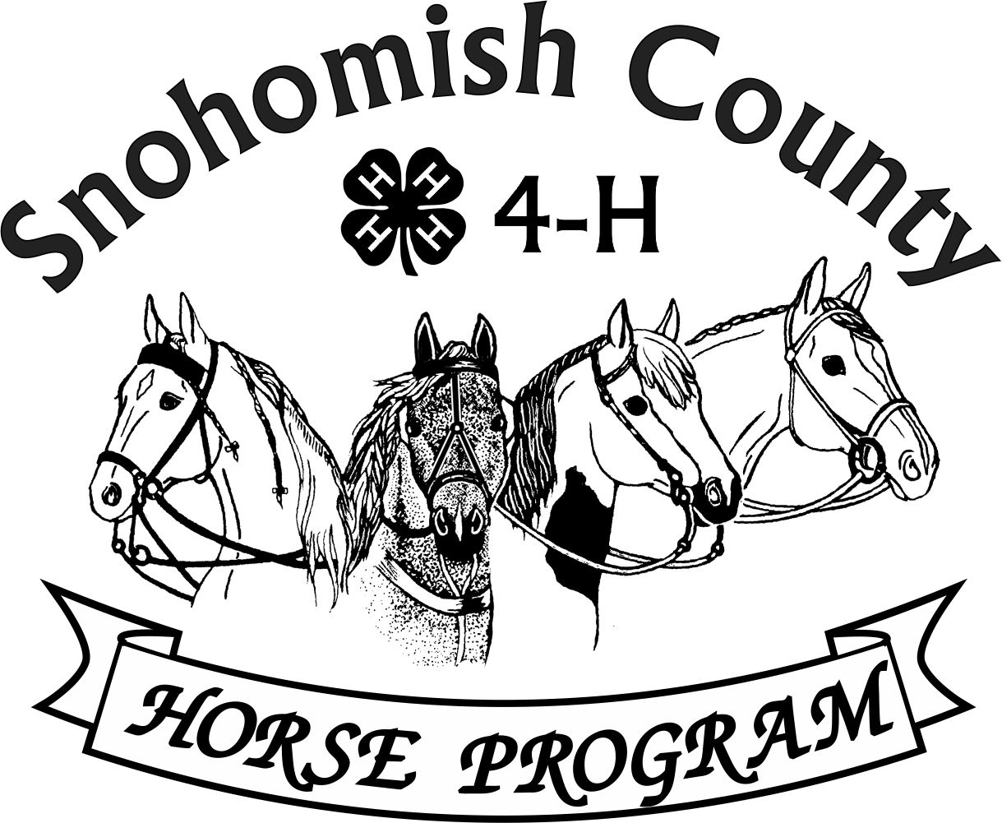

Calendar of Events 4-H Year 2024- 2025

NOVEMBER 2024

***For current updates, check the Horse Program Website at*** [***http://snoco4-hhorse.com/***](http://snoco4-hhorse.com/)

***And on Facebook*** [***Snohomish County 4-H Horse Program***](https://urldefense.com/v3/__https:/www.facebook.com/groups/SnohomishCO4HEquine/?ref=group_header__;!!JmPEgBY0HMszNaDT!7vWm4SARBEwaY3tou7lvJWLoUntVhIjeIfKIFKC44QGkWnV6GeRPaPrXuQ9Rq2oz$)

***NOTE – Members must be enrolled prior to participation in 4-H events***

[***https://v2.4honline.com/#/user/sign-in***](https://v2.4honline.com/#/user/sign-in)

**The State 4-H Equine Rule Book and the County Reference Guide**

**have much information about the Program and Events:**

[**http://snoco4-hhorse.com/reference-guides/**](http://snoco4-hhorse.com/reference-guides/)

**NOVEMBER 2024**

|  |  |  |
| --- | --- | --- |
| SATURDAY | 2 | FALL WESTERN GAMES SHOW - Fairgrounds |
| SUNDAY | 3 | FALL RANCH HORSE SHOW – Eagle Mountain Ranch, Arlington |
| TUESDAY | 5 | RIDE NIGHT 5:30-8:00pm Fairgrounds |
| TUESDAY | 19 | RIDE NIGHT 5:30-8:00pm Fairgrounds |
| THURSDAY | 21 | HORSE PROGRAM MEETING 6:30pm  Good Shepherd Lutheran Church, 5511 64th ST SE, Snohomish  Watch Facebook for Zoom Link |
| FRIDAY | 22 | HORSE BOWL CONTEST #1  6pm Registration 4-H Building, Fairgrounds |
| FRI-SAT | 22-23 | TEEN SUMMIT at Camp Casey on Whidbey Island |
| SATURDAY | 30 | CLINICS WITH AREA PROFESSIONALS (who donate their time!!!)– Fairgrounds  Watch Facebook for details |

**DECEMBER 2024**

|  |  |  |
| --- | --- | --- |
| SUNDAY | 1 | HORSE BOWL CONTEST #2  4pm Registration 4-H Building, Fairgrounds |
| TUESDAY | 3 | RIDE NIGHT 5:30-8:00pm Fairgrounds |
| SATURDAY | 14 | YOUTH LEADERSHIP CONFERENCE (Includes Club Officer Training) Everett WSU |
| TUESDAY | 17 | RIDE NIGHT 5:30-8:00pm Fairgrounds |

**JANUARY 2025**

|  |  |  |
| --- | --- | --- |
| FRIDAY | 3 | HORSE BOWL CONTEST #3  6pm Registration 4-H Building, Fairgrounds |
| TUESDAY | 7 | RIDE NIGHT 5:30-8:00pm Fairgrounds |
| THURSDAY | 16 | HORSE PROGRAM MEETING 6:30pm  Good Shepherd Lutheran Church, 5511 64th ST SE, Snohomish  Watch Facebook for Zoom Link |
| SUNDAY | 19 | HIPPOLOGY CONTEST #1  4 pm Registration 4-H Building, Fairgrounds |
| TUESDAY | 21 | RIDE NIGHT 5:30-8:00pm Fairgrounds |
| FRIDAY | 31 | HIPPOLOGY CONTEST #2  6pm Registration 4-H Building, Fairgrounds |
| FRIDAY | 31 | LAST DAY TO RE-ENROLL WITH NO LATE FEES |

**FEBRUARY 2025**

|  |  |  |
| --- | --- | --- |
|  |  | TBD – ANNUAL AWARDS DESSERT POTLUCK |
| TUESDAY | 4 | RIDE NIGHT 5:30-8:00pm Fairgrounds |
| FRIDAY | 14 | HIPPOLOGY CONTEST #3  6pm Registration 4-H Building, Fairgrounds |
| THURSDAY | 20 | HORSE PROGRAM MEETING 6:30pm  Good Shepherd Lutheran Church, 5511 64th ST SE, Snohomish  Watch Facebook for Zoom Link |
| SUNDAY | 23 | “FALL/WINTER” DRESSAGE & WESTERN DRESSAGE SHOW – Fairgrounds Indoor Arena |
| MONDAY-  FRIDAY | 24-28 | TACK SALE PREPARATIONS – Fairgrounds Event Center and 4-H Building |

**MARCH 2025**

|  |  |  |
| --- | --- | --- |
| SATURDAY | 1 | ANNUAL TACK SALE – Fairgrounds Event Center and 4-H Building |
| SUNDAY | 2 | CONSIGNMENT PICK UP AND FINAL CLEAN UP FOR TACK SALE – Event Center and 4-H Building |
| THURSDAY | 20 | HORSE PROGRAM MEETING 6:30pm  Good Shepherd Lutheran Church, 5511 64th ST SE, Snohomish  Watch Facebook for Zoom Link |
| SATURDAY | 29 | EQUINE-A-RAMA – Fairgrounds |
| MONDAY | 31 | DEADLINE FOR ENROLLING IN 4-H FOR FAIR PARTICIPATION |

**YEARLY INFORMATION AND CONTACTS**

|  |  |
| --- | --- |
| **\*\*HORSE PROGRAM MEETINGS**  Third Thursday of each month (except for December)  *At least one representative per club is requested | Pat Pehling 360-568-4047  [programleader@snoco4-hhorse.com](mailto:programleader@snoco4-hhorse.com) |
| **\*\*YOUTH FORUM**  *At least one representative per club is requested | Nanci Johnson 425-328-0798  [nanci4prez@yahoo.com](mailto:nanci4prez@yahoo.com) |

**KNOWLEDGE**

|  |  |
| --- | --- |
| **EQUINE PRESENTATIONS**  County Contest –  State Contest – March 22, 2025 | Patty Christenson 425-210-6000  [rainbowsend7834@cs.com](mailto:rainbowsend7834@cs.com) |
| **CLOVERBUD/HORSELESS ACTIVITIES**  Watch Calendar and Facebook for information | Patty Christenson 425-210-6000  [rainbowsend7834@cs.com](mailto:rainbowsend7834@cs.com) |
| **GROOM SQUAD CONTESTS**  TBD | Melissa Sweeney  [groomsquad@snoco4-hhorse.com](mailto:groomsquad@snoco4-hhorse.com) |
| **HIPPOLOGY CONTESTS**  #1 –January 19  #2 – January 31  #3 – February 14  State Contest –May 3 | Rianan Livingston 360-722-9507  [hippology@snoco4-horse.com](mailto:hippology@snoco4-horse.com) |

|  |  |
| --- | --- |
| **HORSE BOWL CONTESTS**  #1 – November 22  #2 – December 1  #3 – January 3  State Contest –May 4 | Margaret Cooper  horsebowl@snoco4-hhorse.com |
| **HORSE JUDGING CONTESTS**  #1 – October 24  #2 –  #3 –  #4 –  State Contest – | Pat Pehling 360-568-4047  [programleader@snoco4-hhorse.com](mailto:programleader@snoco4-hhorse.com)  Teresa Smith | |

**SHOWS**

|  |  |
| --- | --- |
| **DRIVING/SMALL EQUINE**  Fall – October 4-5  Spring – March 14-16  Summer – May 30-June 1 | Ginger Kunz 815-904-4432  [ponypower2020@yahoo.com](mailto:ponypower2020@yahoo.com) |
| **DRESSAGE SHOWS**  Fall /Winter – February 23  Spring –  Summer – | Stephanie Portch 425-319-3211  [westerndressage@snoco4-hhorse.com](mailto:westerndressage@snoco4-hhorse.com) |

|  |  |
| --- | --- |
| **HUNTER OVER FENCES SHOWS**  Fall – October 5  Spring – TBD  Summer – TBD  Fall - TBD | Stephanie Castner  [hunteroverfences@snoco4-hhorse.com](mailto:hunteroverfences@snoco4-hhorse.com)  Sandra Green |
| **PERFORMANCE SHOWS**  Fall – October 4-5  Spring – March 14-16  Summer – May 30-June 1  Fall – October  3-5, 2025 | Katie Norris  [performance@snoco4-hhorse.com](mailto:performance@snoco4-hhorse.com)  Laurie Johnson (Show Registrar)  206-930-3844 (text)  [lauriecm@gmail.com](mailto:lauriecm@gmail.com) |
| **RANCH HORSE**  Fall – November 3  Spring – TBD  Summer – TBD  Fall - TBD | Sarah Gunderson 206-290-0506  [sarahgcpa@gmail.com](mailto:sarahgcpa@gmail.com)  Kyri McCoy |

|  |  |
| --- | --- |
| **TRAIL HORSE CLASS IN THE FIELD**  TBD | Ariana Marquez [trailhorseclassinthefield@snoco4-hhorse.com](mailto:trailhorseclassinthefield@snoco4-hhorse.com)  Pat Pehling 425 327 6778  [programleader@snoco4-hhorse.com](mailto:programleader@snoco4-hhorse.com) |
| **WESTERN DRESSAGE SHOWS**  Fall – TBD  Spring – TBD  Summer – TBD  Fall - TBD | Stephanie Portch 425-319-3211 [westerndressage@snoco4-hhorse.com](mailto:westerndressage@snoco4-hhorse.com) | |

|  |  |
| --- | --- |
| **WESTERN GAMES SHOWS**  Fall – November 2  Spring – TBD  Summer – TBD  Fall – November 3,2025 | Billi Startzman 425-344-5873  [westerngames@snoco4-hhorse.com](mailto:westerngames@snoco4-hhorse.com) |

**FAIR**

|  |  |
| --- | --- |
| EVERGREEN STATE FAIR | Melinda Nelson 425-737-2700  [fairsuperintendent@snoco4-hhorse.com](mailto:fairsuperintendent@snoco4-hhorse.com)  Laurie Johnson (Assistant) 206-930-3844 (text)  lauriecm@gmail.com |

**STATE FAIR**

|  |  |
| --- | --- |
| WASHINGTON STATE 4-H FAIR | Pat Pehling 360-568-4047  [programleader@snoco4-hhorse.com](mailto:programleader@snoco4-hhorse.com) |

**NATIONALS**

|  |  |
| --- | --- |
| KENTUCKY NATIONALS 2024  November 9, 2024 | RA Mazzola 206-799-5466  [ramazzola@aol.com](mailto:ramazzola@aol.com)  Pat Pehling 425 327 6778  [programleader@snoco4-hhorse.com](mailto:programleader@snoco4-hhorse.com) |

**TACK SALE**

|  |  |
| --- | --- |
| March 1, 2025 | Pat Pehling 425 327 6778  [programleader@snoco4-hhorse.com](mailto:programleader@snoco4-hhorse.com)  Jennifer Munson 425 471 4532  [munson.jenniferl@gmail.com](mailto:munson.jenniferl@gmail.com) |

**EQUINE-A-RAMA**

|  |  |
| --- | --- |
| March 29, 2025 | Patty Christenson 425-210-6000  [rainbowsend7834@cs.com](mailto:rainbowsend7834@cs.com) |

4-H Horse Program Officers

Pat Pehling – Program Leader

Lindsay Matter - President

Sarah Norris-Hendrickson – Vice President

LaVonne Bowman – Secretary

Billi Startzman – Treasurer