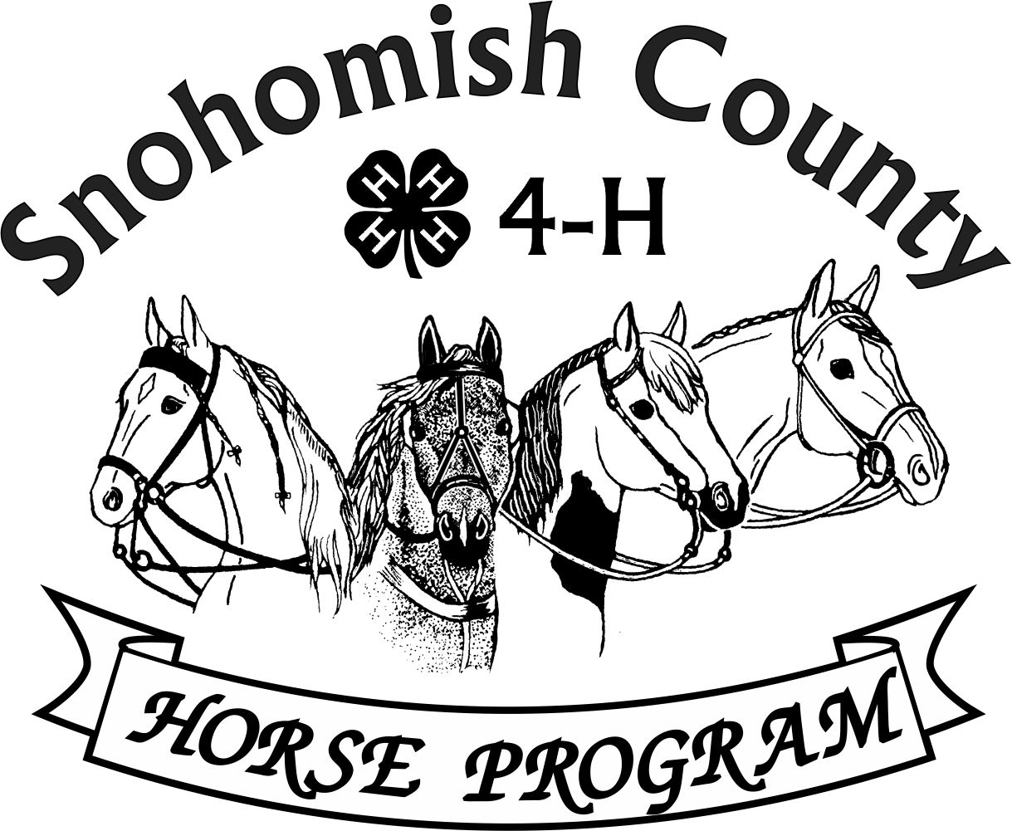

Calendar of Events 4-H Year 2023- 2024

AUGUST 2024

***For current updates, check the Horse Program Website at*** [***http://snoco4-hhorse.com/***](http://snoco4-hhorse.com/)

***And on Facebook*** [***Snohomish County 4-H Horse Program***](https://urldefense.com/v3/__https:/www.facebook.com/groups/SnohomishCO4HEquine/?ref=group_header__;!!JmPEgBY0HMszNaDT!7vWm4SARBEwaY3tou7lvJWLoUntVhIjeIfKIFKC44QGkWnV6GeRPaPrXuQ9Rq2oz$)

***NOTE – Members must be enrolled prior to participation in 4-H events***

[***https://v2.4honline.com/#/user/sign-in***](https://v2.4honline.com/#/user/sign-in)

**Reference Guide has much information about the Program and Events:**

[**http://snoco4-hhorse.com/reference-guides/**](http://snoco4-hhorse.com/reference-guides/)

**AUGUST 2024**

|  |  |  |
| --- | --- | --- |
| THURSDAY | 1 | FAIR COMMITTEE MEETING – 6:30PM Good Shepherd Lutheran Church, 5511 64th ST SE, Snohomish |
| FRIDAY-  SATURDAY | 2-3 | Stanwood-Camano Community Fair Performance Show – (Medals Qualifying for Showmanship and Equitation) – open to all youth regardless of address |
| MONDAY | 12 | DUE DATE ON SHOWORKS FOR HORSE SHOP & PUBLIC PRESENTATIONS |
| THURSDAY | 15 | HORSE PROGRAM MEETING 6:30pm  Good Shepherd Lutheran Church, 5511 64th ST SE, Snohomish  Watch Facebook for Zoom Link |
| SUNDAY- THURSDAY | 18-29 | EVRGREEN STATE FAIR  Clean and Disinfect stalls – August 18-21 (no power-washing after 3pm Sunday)  Horse Shop & Public Presentations entries due – Monday, August 19, 4-7pm  Senior Performance Section haul in and Vet Check – Wednesday, August 21, 5:30-7:30pm  Senior Performance Section released Saturday, 4pm  Western Games & Junior Performance haul in and Vet Check – Saturday, August 24, 5:30-7:30pm  Stick Horse Workshop Sunday, August 25, 10am-12:30pm Events 10:30am-1:15pm  Western Games & Junior Performance released Monday, August 26.  4pm  Intermediate Performance Section haul in and Vet Check-Monday, August 26, 5:30pm-7:30pm  Groom Squad Contest – Wednesday, August 28 (Fair Closed so no passes or Parking fees)  Horse Shop item pick up 1-4pm  Intermediate Performance released Thursday, August 29, 4pm and decoration take down |

**SEPTEMBER 2024**

|  |  |  |
| --- | --- | --- |
|  | 4-22 | WASHINGTON STATE 4-H FAIR **Equine Schedule**:  Wed, September 4 **IN**: Sr Dressage, 5-7pm (Performance may arrive also)  Thurs, September 5 **IN**: Sr Performance, 5-7 pm  Sat, September 7 **OUT**: Sr Dressage, 2 pm (Also Judging and Groom Squad Contests)  Mon, September 9 **OUT**: Sr Performance/Dressage, 2 pm  Wed, September 11 **IN**: Sr Western Games, 5-7 pm  Sat, September 14 **OUT**: Sr Western Games, 2 pm  **IN**: Int & Sr Harness and Small Equine, 5-7pm  Mon, September 16 **OUT**: Int & Sr Harness and Small Equine 5-7pm  Tues, September 17 **IN**: Int Performance/Dressage, 1-3 pm  Thurs, September 19 **OUT**: Int Performance/Dressage, 2 pm  **IN**: Int Western Games, 5-7 pm  Sun, September 22 **OUT**: Int Western Games |
| SATURDAY | 7 | State 4-H Horse Judging Contest - Puyallup  State 4-H Groom Squad Contest - Puyallup |
| THURSDAY | 19 | HORSE PROGRAM MEETING 6:30pm  Good Shepherd Lutheran Church, 5511 64th ST SE, Snohomish  Watch Facebook for Zoom Link |

**OCTOBER 2024**

|  |  |  |
| --- | --- | --- |
| FRIDAY-SUNDAY | 4-6 | FALL PEFORMANCE SHOWS – Fairgrounds  Driving Classes Friday afternoon/evening, Western & Small Equine Saturday, HOF Saturday afternoon/evening, English Sunday |
| THURSDAY | 19 | HORSE PROGRAM MEETING 6:30pm  Good Shepherd Lutheran Church, 5511 64th ST SE, Snohomish  Watch Facebook for Zoom Link |

**YEARLY INFORMATION AND CONTACTS**

|  |  |
| --- | --- |
| **\*\*HORSE PROGRAM MEETINGS**  Third Thursday of each month (except for December)  *At least one representative per club is requested | Pat Pehling 360-568-4047  [programleader@snoco4-hhorse.com](mailto:programleader@snoco4-hhorse.com) |
| **\*\*YOUTH FORUM**  *At least one representative per club is requested | Nanci Johnson 425-328-0798  [nanci4prez@yahoo.com](mailto:nanci4prez@yahoo.com) |

**KNOWLEDGE**

|  |  |
| --- | --- |
| **EQUINE PRESENTATIONS**  County Contest – January 20, 2024  State Contest – February 3,2024  *State Contest – March 22, 2025* | Patty Christenson 425-210-6000  [rainbowsend7834@cs.com](mailto:rainbowsend7834@cs.com) |
| **CLOVERBUD/HORSELESS ACTIVITIES**  Watch Calendar and Facebook for information | Patty Christenson 425-210-6000  [rainbowsend7834@cs.com](mailto:rainbowsend7834@cs.com) |
| **GROOM SQUAD CONTESTS**  TBD | Melissa Sweeney  [groomsquad@snoco4-hhorse.com](mailto:groomsquad@snoco4-hhorse.com) |
| **HIPPOLOGY CONTESTS**  #1 –January 12  #2 – February 4  #3 – February 16  State Contest –May 4 | Rianan Livingston 360-722-9507  [hippology@snoco4-horse.com](mailto:hippology@snoco4-horse.com) |

|  |  |
| --- | --- |
| **HORSE BOWL CONTESTS**  #1 – November 12  #2 – December 1  #3 – December 15  State Contest –May 5 | Need chair  horsebowl@snoco4-hhorse.com |
| **HORSE JUDGING CONTESTS**  #1 – October 24  #2 – April 30  #3 – May 23  #4 – June 2  State Contest – September 7 | Pat Pehling 360-568-4047  [programleader@snoco4-hhorse.com](mailto:programleader@snoco4-hhorse.com)  Teresa Smith | |

**SHOWS**

|  |  |
| --- | --- |
| **DRIVING**  Fall – October 6  Spring – March 15  Summer – June 22 | Ginger Kunz 815-904-4432  [ponypower2020@yahoo.com](mailto:ponypower2020@yahoo.com) |
| **DRESSAGE SHOWS**  Fall – February 25 (Rescheduled)  Spring – May 5  Summer – July 21 | Stephanie Portch 425-319-3211  [westerndressage@snoco4-hhorse.com](mailto:westerndressage@snoco4-hhorse.com) |

|  |  |
| --- | --- |
| **HUNTER OVER FENCES SHOWS**  Fall – October 7  Spring – March 16  Summer – June 21 | Stephanie Castner  [hunteroverfences@snoco4-hhorse.com](mailto:hunteroverfences@snoco4-hhorse.com)  Sandra Green (Show Registrar) |
| **PERFORMANCE SHOWS**  Fall – October 6-8  Spring – March 15-17  Summer – June 21-23  Fall – October 4-6, 2024  2025:  March 14-16  May 30-June 1  October  3-5 | Katie Norris  [performance@snoco4-hhorse.com](mailto:performance@snoco4-hhorse.com)  Laurie Johnson (Show Registrar)  206-930-3844 (text)  [lauriecm@gmail.com](mailto:lauriecm@gmail.com) |
| **RANCH HORSE**  Fall – October 22, 2023  Spring – April 14  Summer – July 14  **SMALL EQUINE SHOWS**  Fall – October 7  Spring – March 16  Summer – June 23 | Sarah Gunderson 206-290-0506  [sarahgcpa@gmail.com](mailto:sarahgcpa@gmail.com)  Ginger Kunz 815-904-4432  [ponypower2020@yahoo.com](mailto:ponypower2020@yahoo.com) |

|  |  |
| --- | --- |
| **TRAIL HORSE CLASS IN THE FIELD**  TBD | Ariana Marquez [trailhorseclassinthefield@snoco4-hhorse.com](mailto:trailhorseclassinthefield@snoco4-hhorse.com)  Pat Pehling 425 327 6778  [programleader@snoco4-hhorse.com](mailto:programleader@snoco4-hhorse.com) |
| **WESTERN DRESSAGE SHOWS**  Fall – February 25 (Rescheduled)  Spring – May 5  Summer – July 21 | Stephanie Portch 425-319-3211 [westerndressage@snoco4-hhorse.com](mailto:westerndressage@snoco4-hhorse.com) | |

|  |  |
| --- | --- |
| **WESTERN GAMES SHOWS**  Fall – November 4  Spring – February 24  Summer – June 9  Fall – November 3 | Billi Startzman 425-344-5873  [westerngames@snoco4-hhorse.com](mailto:westerngames@snoco4-hhorse.com) |

**FAIR**

|  |  |
| --- | --- |
| EVERGREEN STATE FAIR  August 18-29 | Melinda Nelson 425-737-2700  [fairsuperintendent@snoco4-hhorse.com](mailto:fairsuperintendent@snoco4-hhorse.com)  Laurie Johnson (Assistant) 206-930-3844 (text)  lauriecm@gmail.com |

**STATE FAIR**

|  |  |
| --- | --- |
| WASHINGTON STATE 4-H FAIR  September 2024 (Schedule not yet available) | Pat Pehling 360-568-4047  [programleader@snoco4-hhorse.com](mailto:programleader@snoco4-hhorse.com) |

**NATIONALS**

|  |  |
| --- | --- |
| KENTUCKY NATIONALS 2024  November 2024 | RA Mazzola 206-799-5466  [ramazzola@aol.com](mailto:ramazzola@aol.com)  Pat Pehling 425 327 6778  [programleader@snoco4-hhorse.com](mailto:programleader@snoco4-hhorse.com) |

**TACK SALE**

|  |  |
| --- | --- |
| March 1, 2025 | Pat Pehling 425 327 6778  [programleader@snoco4-hhorse.com](mailto:programleader@snoco4-hhorse.com)  Jennifer Munson 425 471 4532  [munson.jenniferl@gmail.com](mailto:munson.jenniferl@gmail.com) |

**EQUINE-A-RAMA**

|  |  |
| --- | --- |
| March 23 | Patty Christenson 425-210-6000  [rainbowsend7834@cs.com](mailto:rainbowsend7834@cs.com) |

4-H Horse Program Officers

Pat Pehling – Program Leader

Lindsay Matter - President

Sarah Norris-Hendrickson – Vice President

LaVonne Bowman – Secretary

Billi Startzman – Treasurer