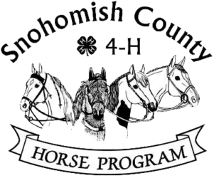

Attention: College-bound Seniors:
Are you in your final year of 4-H eligibility and/or entering college next fall? Have you been a member of the Snohomish County 4-H Horse program for at least three years? College is expensive – we can help! The 4-H Horse Program offers three college scholarships each year to Snohomish County 4-H Horse Program members who will be entering their first or second year of post-secondary education. This can be to any accredited college, university or trade school , and taking a “gap” year is allowed. Two scholarships are for $1,500.00 each, and the highest scoring applicant will receive a $2,000.00 scholarship.
The application is a two-part process. First you submit a completed packet, which contains your application, an essay, two letters of recommendation, and your permanent record book. Completed application packets should be returned to the new Extension Office location at 6705 Puget Park Drive, Snohomish, WA 98296. Hours are Monday – Friday, 8am – 5pm. Application deadline is April 1. This phase is scored by a panel of judges, and the top ten scoring applicants are invited to participate in the second phase, which is a personal interview, and takes place in mid-May.
To apply for a scholarship you will need these documents:
Scholarship Checklist
Scholarship Guidelines
Scholarship Application form
Scholarship Reference form (You will need two of these}
Scholarship Essay Directions

Application packets are available on the Extension website:https://extension.wsu.edu/snohomish/4h/programs/animal-science/horse-program-scholarship/
or on the Horse Program website: http://snoco4-hhorse.com/
Questions? Contact Pat Pehling pehling@frontier.com or 425-327-6778

