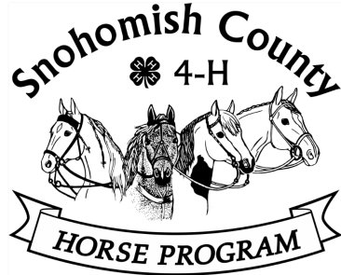
Snohomish County 4-H Horse Program
Scholarship Application Checklist

- Read the Scholarship Guidelines. Get any questions answered. (Phone Pat Pehling at 425-327-6778 or email pehling@frontier.com
- Return your completed application packet to the Extension Office, 6705 Puget Park Drive, Snohomish, WA, 98296. Hours are 8am- 5pm.
- Before submitting your completed application, use this checklist to be sure you have included all the required documents.
- All bolded items must be included in the application packet.

  - Scholarship Application Form – must include 3 signatures.

  - Two Reference Forms – one to be completed by Club Leader or Project Leader and the other by a teacher, community member, equine professional, 4-H volunteer, etc. (May not be the applicant’s parent or other close family member). Both reference letters are to be returned to the applicant in sealed envelopes.

  - Essay – separate page, signed, 500 word maximum.

  - Permanent Record – up-to-date (current year may be in pencil).

*****************Important Dates******************

Jan. 10 Application packets available at the monthly Horse Program meetings, on Extension website, https://extension.wsu.edu/snohomish/4h/programs/animal-science/horse-program-scholarship/
or on the Horse Program website, https://snoco4-hhorse.com/.

April 1 Completed application packets due to Extension Office by April 1. If mailed, must be postmarked by April 1.

Early April Selection Committee scores applications

Mid April Finalists notified, group interview schedule established

Mid May Evening interviews with finalists at Extension Office/zoom meeting

Mid-late May Scholarship recipients notified; scholarships announced

Mid July Scholarship funds forwarded to recipients’ schools

