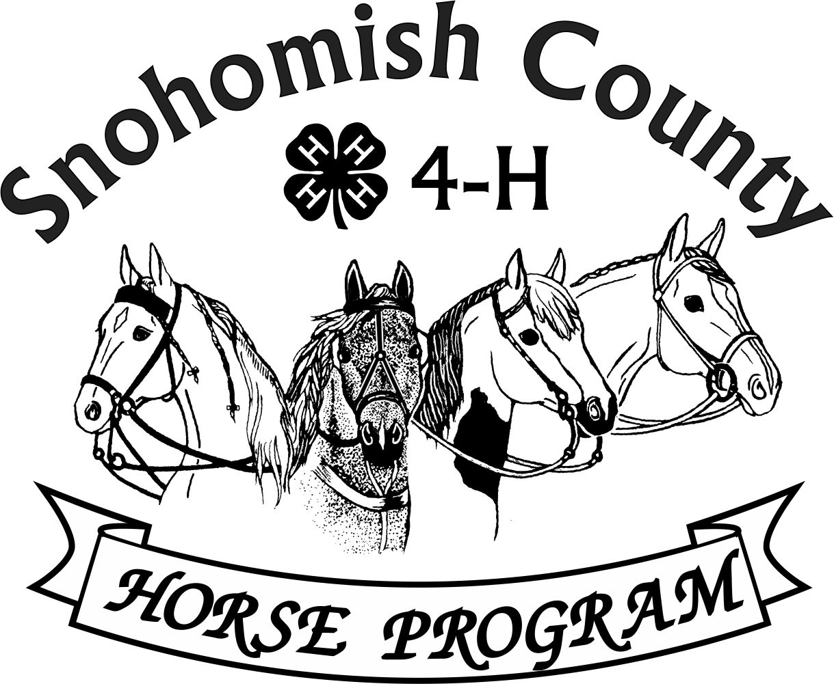
ANGEL METCALF MEMORIAL SPORTSMANSHIP AWARD
Angel Metcalf was a valued volunteer for many years and passed away after battling cancer. This award was designed by Youth Forum to honor her dedication to the Program and recognize youth for outstanding Sportsmanship.
Each year every Club may submit a nomination for this award (selected by the Club members). Nominees all receive a special pin and certificate. A panel of volunteers scores each nomination (which is anonymous) and the top nominee is recognized with a plaque and a traveling trophy.
DUE November 15th
This award is to recognize a member who has displayed a good work ethic, being a positive role model, encourager, helper, and someone who works to make sure others are welcome.
**This is not based on horsemanship or ability to compete, but solely on kindness and generosity!
This is what we need you to do:
• Have your club MEMBERS vote for someone they want to be honored for this award
• Peers submit their recommendation to their leader with examples as to why they chose this member
•ADULTS DO NOT PICK THE MEMBER
• Club Leader writes a letter based on peer recommendations and their observations also include input from the members in the letter
• These are all submitted to Nanci who will then make the nominees anonymous and have a committee review them
• The committee will select one final candidate to receive the award at the End of Year Award Ceremony
End of Year Awards
• Each nominee will get a certificate and a pin
• The recipient of the Angel Metcalf Memorial Sportsmanship Award will receive a traveling trophy, certificate, pin and patch to put on their jacket.
Please get these back to me before November 15th so we have enough time to get the awards finalized.
Send to nanci4prez@yahoo.com

